**SAVE THE DATE**

**LIFE SCIENCES IP EVENT 2023**

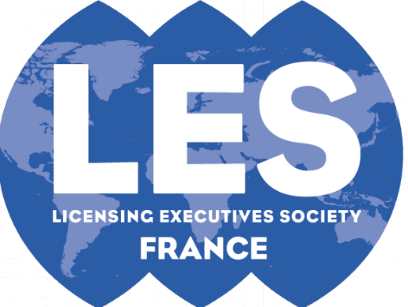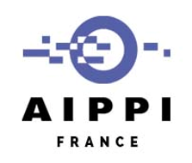

**June 8, 2023**

**1:30 pm – 6:00 pm  
In Paris & Videoconference**

**Venue: Espace Hamelin – 17 rue de l’Amiral Hamelin, 75016 Paris**

**Cocktail at 6:00 pm for attendees in Paris**

1:30 pm – Welcome (Alain Werner – ASPI Vice President)

Moderator - Cyra Nargolwalla (Plasseraud IP)

2:00 pm - Case Law in Europe

NL - Gertjan Kuipers (De Brauw)

UK - Penny Gilbert (Powell Gilbert)

DE - Jürgen Meier (Vossius & Partner)

FR - Thomas Bouvet (Jones Day) & Frédéric Portal (Bird & Bird)

3:45 pm - Coffee Break

4:15 pm - Future European Legislation on Drugs

5:15 pm - Report on Compulsory Licensing

Introduction – Pierick Rousseau (Former IP Director at Pierre Fabre)

6:00 pm - Cocktail

**More information - including the link for registration - will be provided**